**Graphics and multimedia**

**Create a simple 3D model using Blender**

**EXPERIMENT** : 10

**ROLL NO** : 231701012

**NAME** : DIVYA DHARRSHAN T

**--------------------------------------------------------------------------------------------------------------------------------------**

**AIM**

To create and render a simple 3D house model using Blender and apply basic shading and textures.

**Procedure**

1. Open Blender and delete default objects if needed.
2. Add a Cube and scale it to form the base of the house.
3. Add another Cube, scale it to a smaller size, and place it on top as the roof base.
4. Use the Edit Mode → Scale & Extrude to shape the roof (or replace with a pyramid-like shape).
5. Add a Plane and scale it to form the ground.
6. Insert smaller cubes for door and windows.
7. Apply different Materials and Colors:
   * Grey/white for walls
   * Brown/yellow for door
   * Orange/red for roof
   * Green for ground
8. Add a Light source (Sun/Point light) for illumination.
9. Switch to Shading tab → Apply Principled BSDF for basic shading.
10. Render the scene to visualize the house.

**OUTPUT**

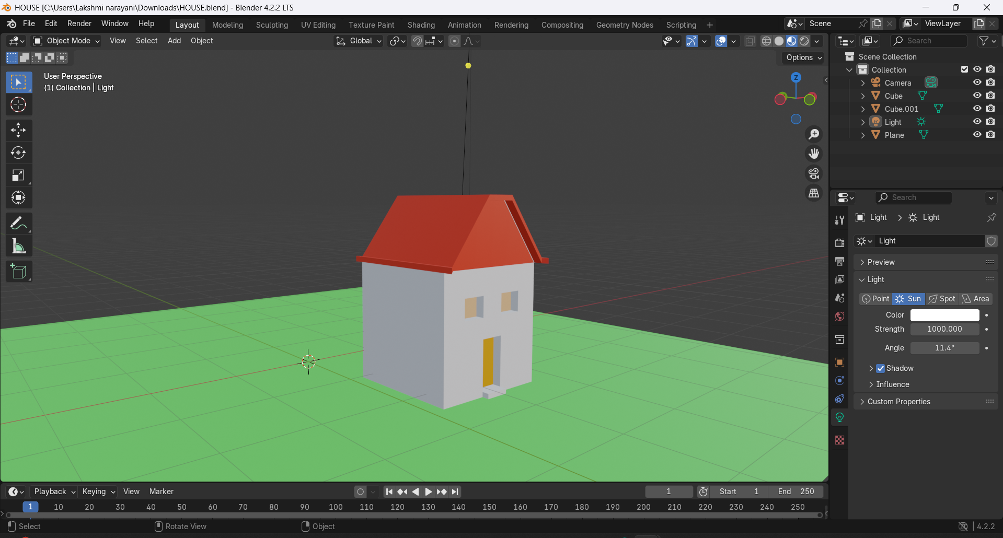

**Result**

A simple 3D house model was created in Blender. Basic colors and shading were applied to the walls, roof, door, windows, and ground, and the model was successfully rendered with lighting.